**Tableau Assignment- 1**

**1. Overview of Tableau Interface:**

**○ Describe the main components of the Tableau interface. Identify the purpose of**

**the Data Pane, Analytics Pane, Marks Card, and Show Me panel.**

Ans:

**Data Pane**

* **Purpose**: The Data Pane displays all the data sources connected to your Tableau workbook.
* **Components**: It includes dimensions (categorical data) and measures (quantitative data) from your data source.
* **Functionality**: Users can drag and drop fields from the Data Pane onto the canvas to create visualizations. It also allows for data organization, including grouping, hierarchies, and calculations.

**Analytics Pane**

* **Purpose**: The Analytics Pane provides tools for adding analytical features to your visualizations.
* **Components**: It includes options for trend lines, reference lines, forecasts, clusters, and more.
* **Functionality**: Users can drag and drop analytical features onto visualizations to enhance data insights and highlight patterns or trends.

**Marks Card**

* **Purpose**: The Marks Card controls the appearance and behavior of the data points in your visualizations.
* **Components**: It includes options for adjusting color, size, label, detail, and tooltip for the marks (data points) in the visualization.
* **Functionality**: Users can customize how data is displayed, making it easier to convey insights and highlight key information in a visually appealing way.

**Show Me Panel**

* **Purpose**: The Show Me panel offers a variety of visualization types that can be created based on the selected fields.
* **Functionality**: When you select data fields in the canvas, the Show Me panel suggests appropriate visualization types (e.g., bar charts, line graphs, scatter plots) based on the dimensions and measures chosen. This helps users quickly find the best way to visualize their data.

**2. Connecting to Data Sources:**

**○ Connect to the "Superstore" sample dataset provided by Tableau. Provide a**

**screenshot of your data source connection.**

Ans:

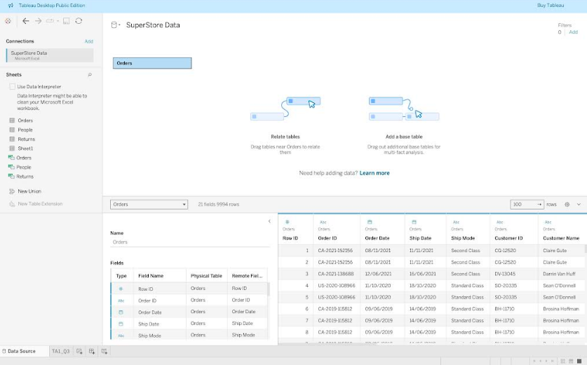

**3. Creating Simple Visualizations:**

**○ Using the "Superstore" dataset, create a bar chart that shows total sales by**

**category. Provide a screenshot of your visualization.**

Ans:

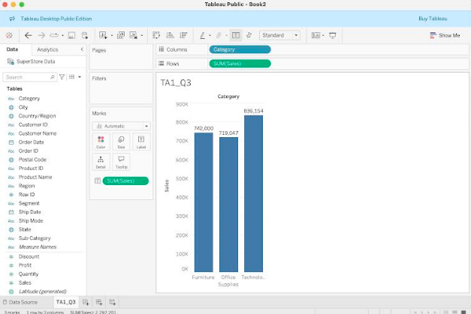

**4. Tableau Worksheet and Dashboard Basics:**

**○ Create a new dashboard that includes the bar chart from Question 3 and a text**

**box with the title "Sales by Category Dashboard". Provide a screenshot of your**

**dashboard.**

Ans:

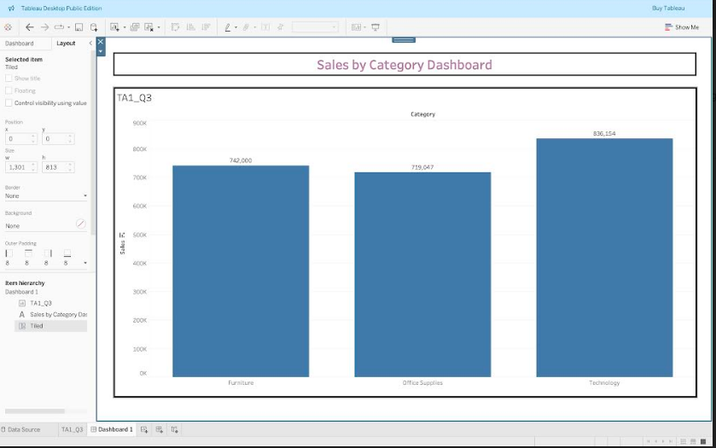

**5. Connecting to Different Data Sources:**

**○ Connect to an Excel file named "SalesData.xlsx" and a CSV file named**

**"CustomerData.csv". Blend these data sources in Tableau to create a**

**visualization that shows total sales by customer region. Provide a screenshot of**

**your data connections and the resulting visualization.**

Ans:

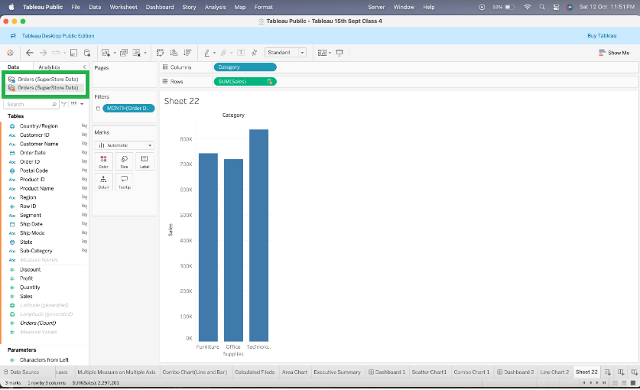

**6. Data Blending and Joins:**

**○ Using the data sources from Question 5, perform a data join to combine the**

**"SalesData" and "CustomerData" tables on the "CustomerID" field. Create a**

**visualization that shows total sales by customer region and customer segment.**

**Provide a screenshot of your join and the resulting visualization.**

Ans:

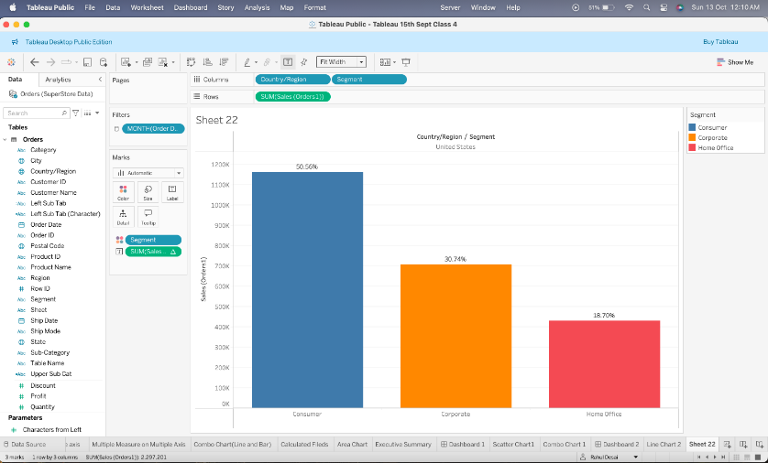

**7. Data Cleaning and Shaping:**

**○ Using the "Superstore" dataset, identify and handle any null values in the "Sales"**

**and "Profit" fields. Provide a screenshot of the cleaned data.**

Ans:

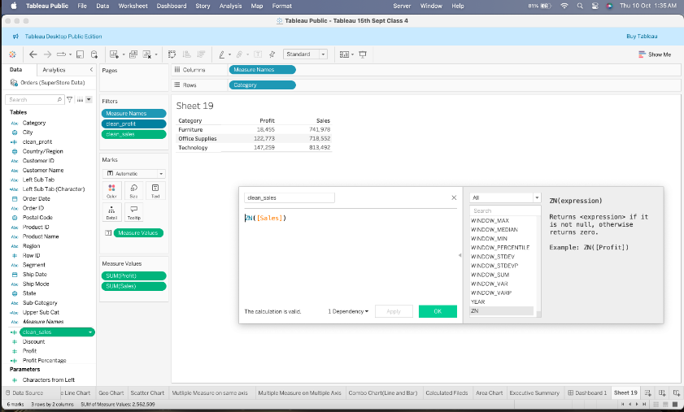

**8. Working with Extracts and Live Connections:**

**○ Explain the difference between extracts and live connections in Tableau. Create**

**an extract of the "Superstore" dataset and provide a screenshot of your extract**

**settings.**

Ans:

**Live Connections**

* **Real-Time Data**: Live connections pull data directly from the data source in real-time. Any changes in the source are immediately reflected in Tableau.
* **Data Volume**: Suitable for smaller datasets where real-time analysis is crucial.
* **Performance**: Performance can be affected by the speed of the data source. Complex queries or large datasets may lead to slower performance.
* **Updates**: Each interaction with the dashboard may require a query to the database, leading to potential delays depending on the source's responsiveness.

**Extract Connections**

* **Static Snapshot**: Extracts create a snapshot of the data at a specific point in time. You can refresh the extract periodically to get updated data.
* **Data Volume**: Better for larger datasets, as extracts can handle larger volumes without impacting performance as severely as live connections.
* **Performance**: Generally faster, as data is stored in Tableau's highly optimized format, reducing query time. Ideal for complex calculations and aggregations.
* **Flexibility**: Allows you to use data offline or when the data source is not available.

**9. Data Types and Roles:**

**○ In the "Superstore" dataset, change the data type of the "Order Date" field to**

**"Date" if it is not already set. Create a line chart that shows total sales over time.**

**Provide a screenshot of your data type change and the resulting line chart.**

Ans:

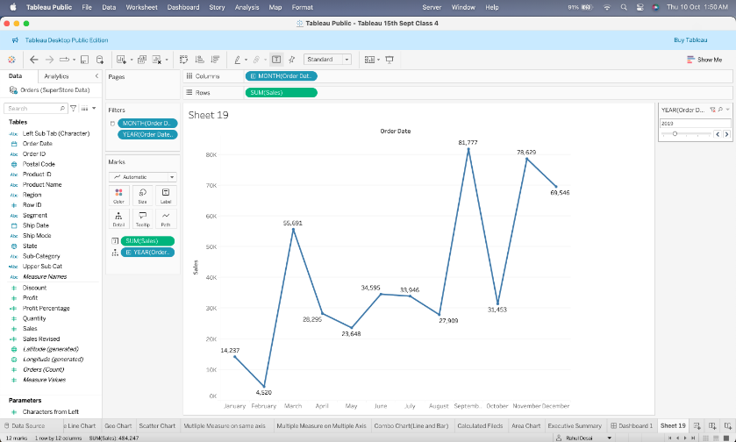

**10. Generated Fields:**

**○ Create a calculated field named "Profit Ratio" in the "Superstore" dataset, which**

**is defined as SUM([Profit]) / SUM([Sales]). Use this field to create a**

**heat map that shows the profit ratio by category and sub-category. Provide a**

**screenshot of your calculated field and the resulting heat map.**

Ans:

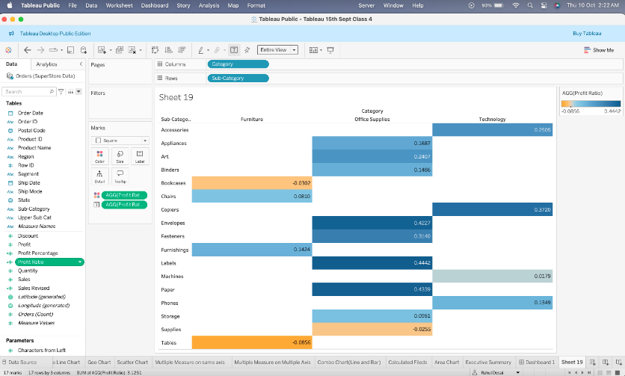

**11. Advanced Data Preparation:**

**○ Using the "Superstore" dataset, create a parameter that allows the user to select**

**a region (e.g., East, West, Central, South). Use this parameter to filter a bar chart**

**that shows total sales by category for the selected region. Provide a screenshot**

**of your parameter setup and the resulting visualization.**

Ans:

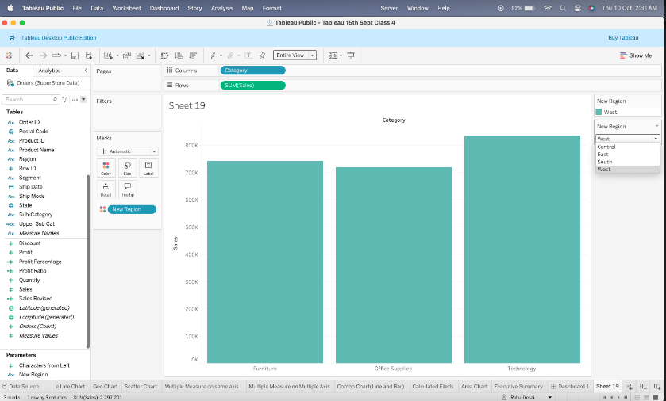

**12. Table Calculations:**

**○ Create a table calculation that shows the year-over-year growth in sales. Use the**

**"Superstore" dataset to create a line chart with this table calculation. Provide a**

**screenshot of your table calculation and the resulting line chart.**

Ans:

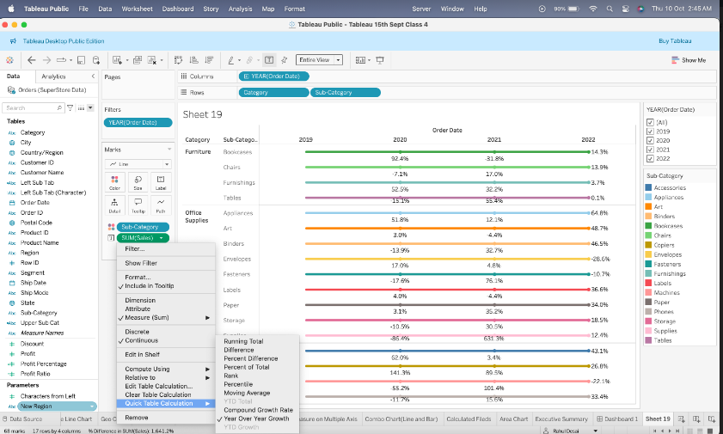

**13. Level of Detail (LOD) Expressions:**

**○ Create an LOD expression to calculate the average sales per customer in the**

**"Superstore" dataset. Use this LOD expression to create a scatter plot that shows**

**average sales per customer by region. Provide a screenshot of your LOD**

**expression and the resulting scatter plot.**

Ans:

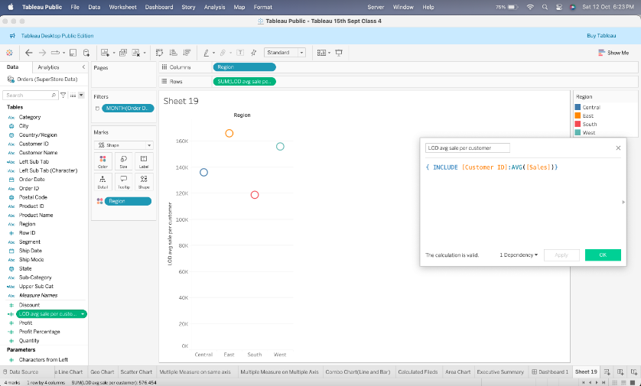

**14. Advanced Visualization Techniques:**

**○ Create a dual-axis chart that combines a bar chart showing total sales and a line**

**chart showing profit ratio by month using the "Superstore" dataset. Provide a**

**screenshot of your dual-axis chart.**

Ans:

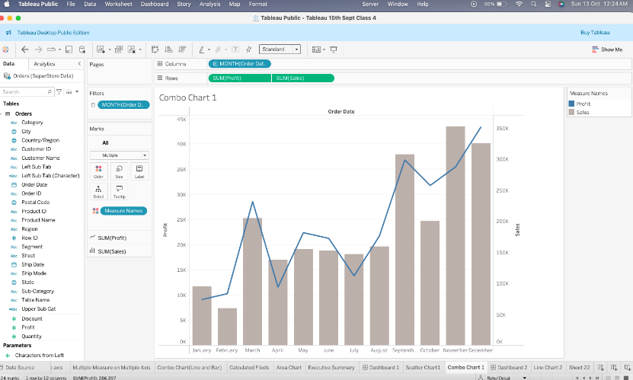

**15. Creating Interactive Dashboards:**

**○ Create an interactive dashboard that includes at least three different**

**visualizations from the previous questions. Add interactivity such as filters,**

**highlight actions, and parameter controls. Provide a screenshot of your**

**interactive dashboard.**

Ans:

